**2a)**

*import* { Component } *from* '@angular/core';

@Component({

  selector: 'app-root',

  templateUrl: './app.component.html',

  styleUrl: './app.component.css'

})

*export* class AppComponent {

  isAuthenticated!: boolean;

  submitted = false;

  userName!: string;

  onSubmit(*name*: string, *password*: string) {

    this.submitted = true;

    this.userName = *name*;

*if*(*name* === 'admin' && *password* === 'admin')

    {

      this.isAuthenticated = true;

    }

*else*

    {

      this.isAuthenticated = false;

    }

  }

}

<div *ngIf="!submitted">

  <form>

    <label>User Name</label>

    <input type="text" #username><br><br>

    <label for="password">Password</label>

    <input type="password" name="password" #password><br><br>

  </form>

  <button (click)="onSubmit(username.value, password.value)">Login</button>

</div>

<div *ngIf="submitted">

  <div *ngIf="isAuthenticated; *else* failureMsg">

    <h4>Welcome {{ userName }}</h4>

  </div>

  <ng-template #failureMsg>

    <h4>Invalid Login!!! Please try again...</h4>

  </ng-template>

  <button type="button" (click)="submitted = false">Back</button>

</div>

<!doctype html>

<html lang="en">

<head>

  <meta charset="utf-8">

  <title>MyApp</title>

  <base href="/">

  <meta name="viewport" content="width=device-width, initial-scale=1">

  <link rel="icon" type="image/x-icon" href="favicon.ico">

</head>

<body>

  <app-root></app-root>

</body>

</html>

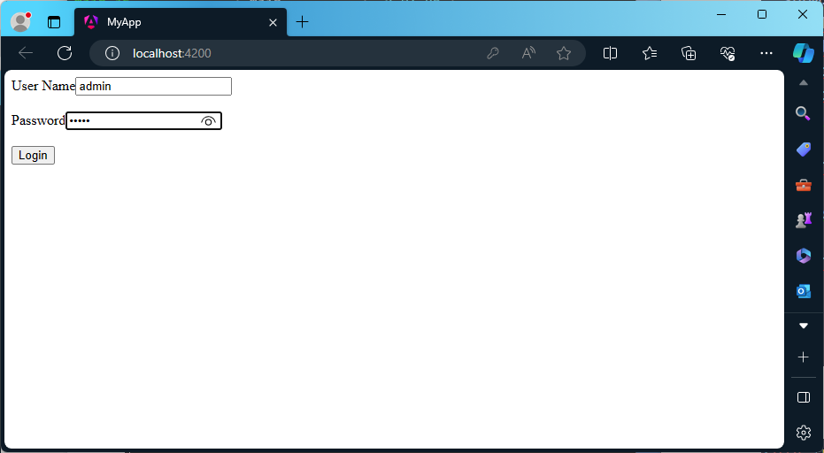

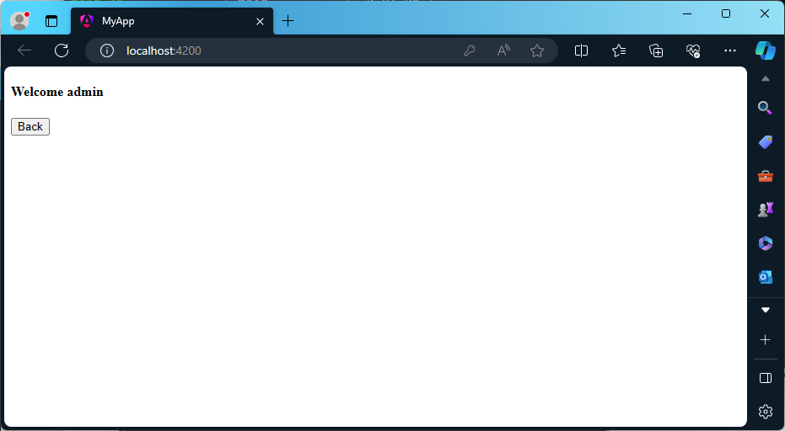

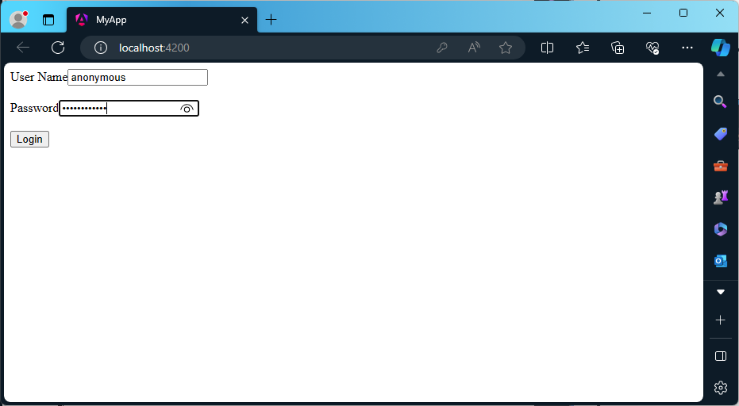

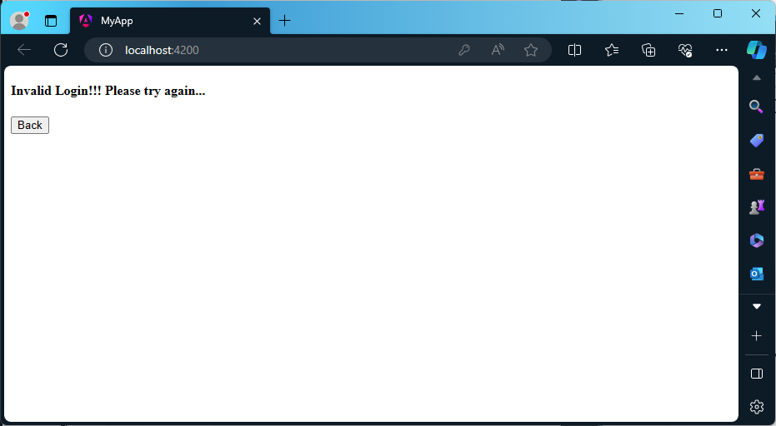

**2b)**

*import* { Component } *from* '@angular/core';

@Component({

  selector: 'app-root',

  templateUrl: './app.component.html',

  styleUrls: ['./app.component.css']

})

*export* class AppComponent {

  courses: any[] = [

    { id: 1, name: 'TypeScript' },

    { id: 2, name: 'Angular' },

    { id: 3, name: 'Node JS' },

    { id: 4, name: 'TypeScript' }

  ];

}

<ul>

  <li *ngFor="let course of courses; let i = index">

    {{ i }} - {{ course.name }}

  </li>

</ul>

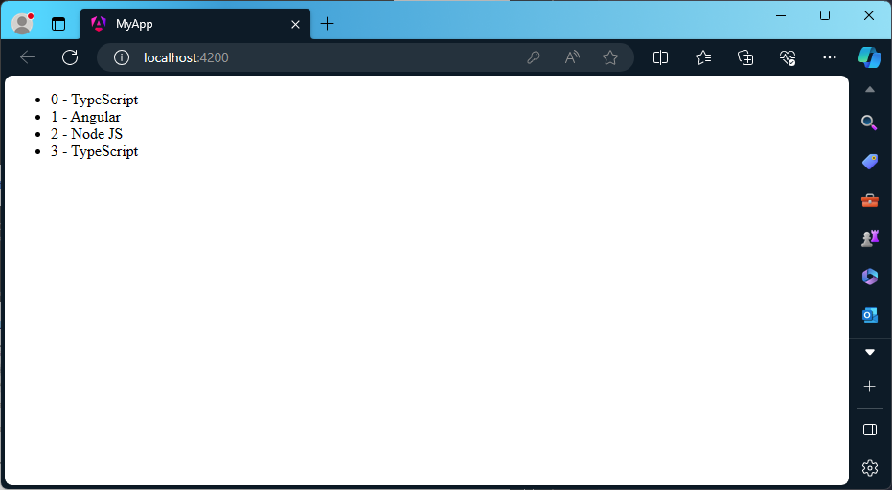

**2c)**

*import* { Component } *from* '@angular/core';

@Component({

  selector: 'app-root',

  templateUrl: './app.component.html',

  styleUrls: ['./app.component.css']

})

*export* class AppComponent {

  choice = 0;

  nextChoice() {

    this.choice++;

  }

}

<h4>

  Current choice is {{ choice }}

</h4>

<div [ngSwitch]="choice">

  <p *ngSwitchCase="1">First Choice</p>

  <p *ngSwitchCase="2">Second Choice</p>

  <p *ngSwitchCase="3">Third Choice</p>

  <p *ngSwitchCase="2">Second Choice Again</p>

  <p *ngSwitchDefault>Default Choice</p>

</div>

<div>

  <button (click)="nextChoice()">

    Next Choice

  </button>

</div>

